**Assignment**

**Date: 20/04/2022**

**Submission Date:**

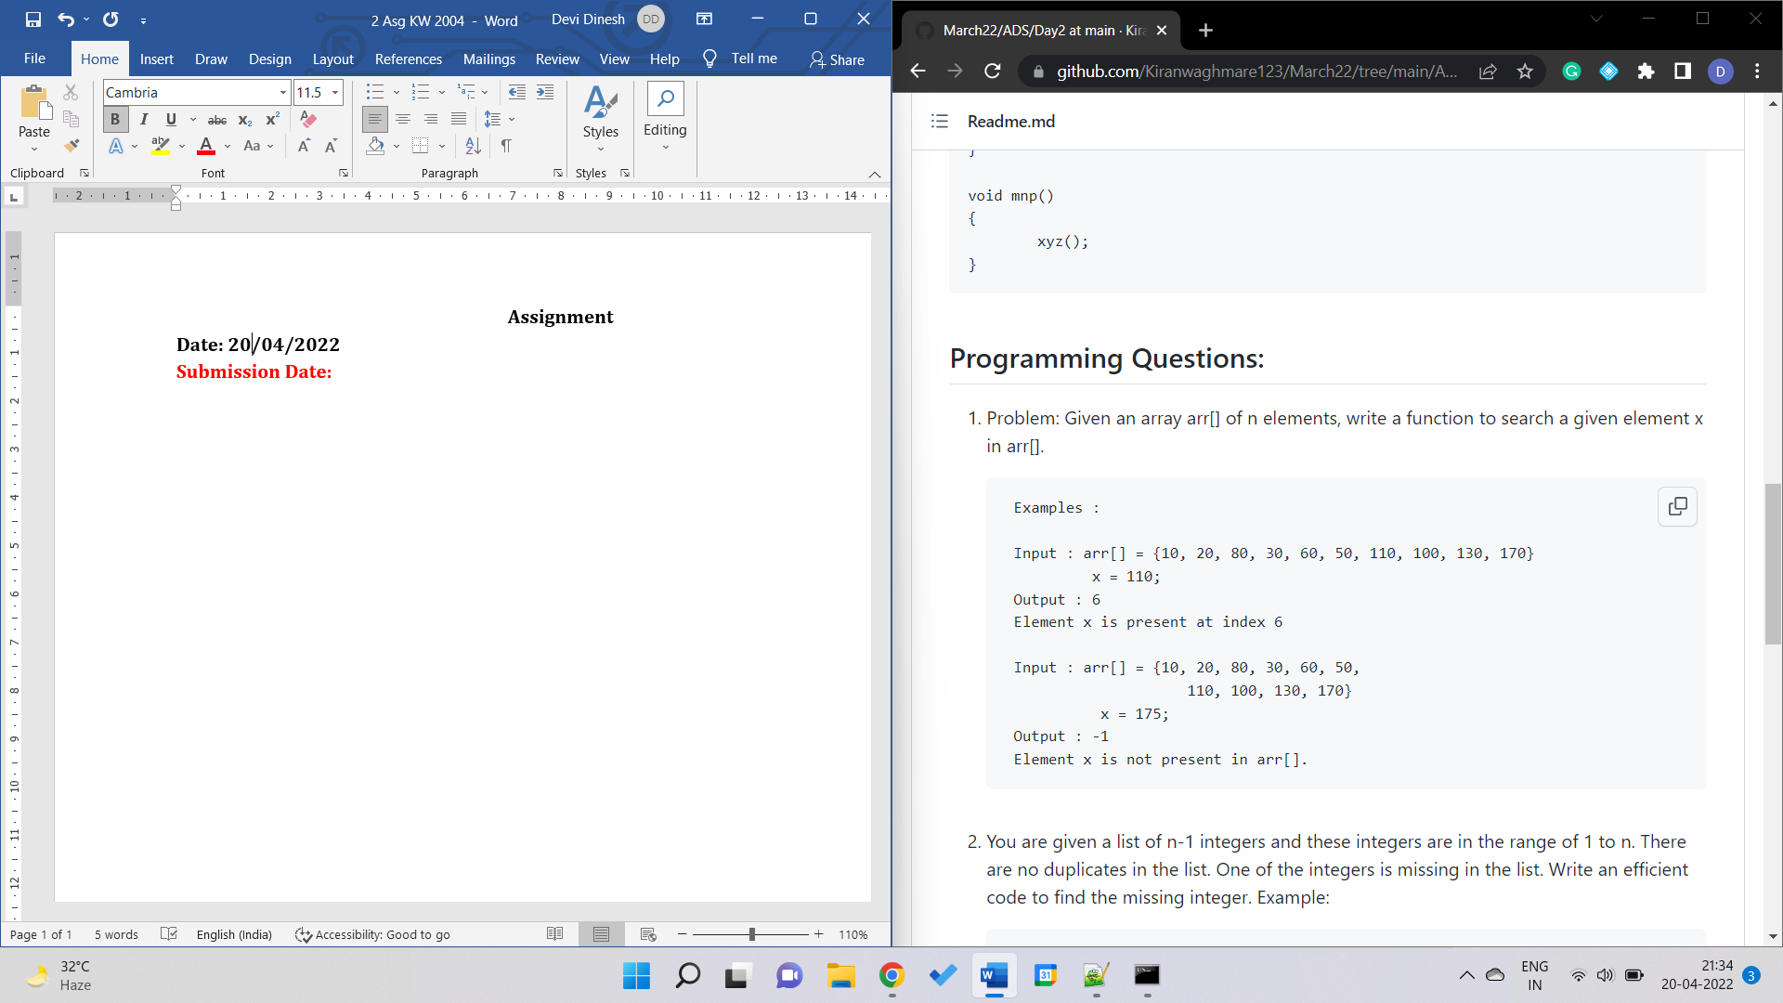

(Linear Search 1)

import java.util.*;

class Test{

static int linearSearch(int key, int arr[]){

for(int i=0; i<arr.length; i++){

if(arr[i]==key)

return i;

}

return -1;

}

public static void main(String args[]){

Scanner sc= new Scanner(System.in);

System.out.print("Enter the number of elements in the array: ");

int n=sc.nextInt();

System.out.print("Enter the elements in the array: ");

int a[]=new int [n];

for(int i=0; i<n; i++)

a[i]=sc.nextInt();

System.out.print("Enter the elements to search: ");

int key=sc.nextInt();

int result=linearSearch(key, a);

if(result ==-1)

System.out.print("Element NOT found");

else

System.out.print("Element found at index number "+result);

}

}

(Binary Search 1)

import java.util.*;

class Test2{

static int binarySearch(int key, int arr[],int l,int h){

int mid=l+(h-l)/2;

if(h>=l){

if(arr[mid]==key)

return mid;

else if (arr[mid]>key)

return binarySearch(key, arr,l,mid-1);

else

return binarySearch(key, arr,mid+1,h);

}

return -1;

}

public static void main(String args[]){

Scanner sc= new Scanner(System.in);

System.out.print("Enter the number of elements in the array: ");

int n=sc.nextInt();

System.out.print("Enter the elements in the array: ");

int a[]=new int [n];

for(int i=0; i<n; i++)

a[i]=sc.nextInt();

System.out.print("Enter the elements to search: ");

int key=sc.nextInt();

int result=binarySearch(key, a,0,n-1);

if(result ==-1)

System.out.print("Element NOT found");

else

System.out.print("Element found at index number "+result);

}

}

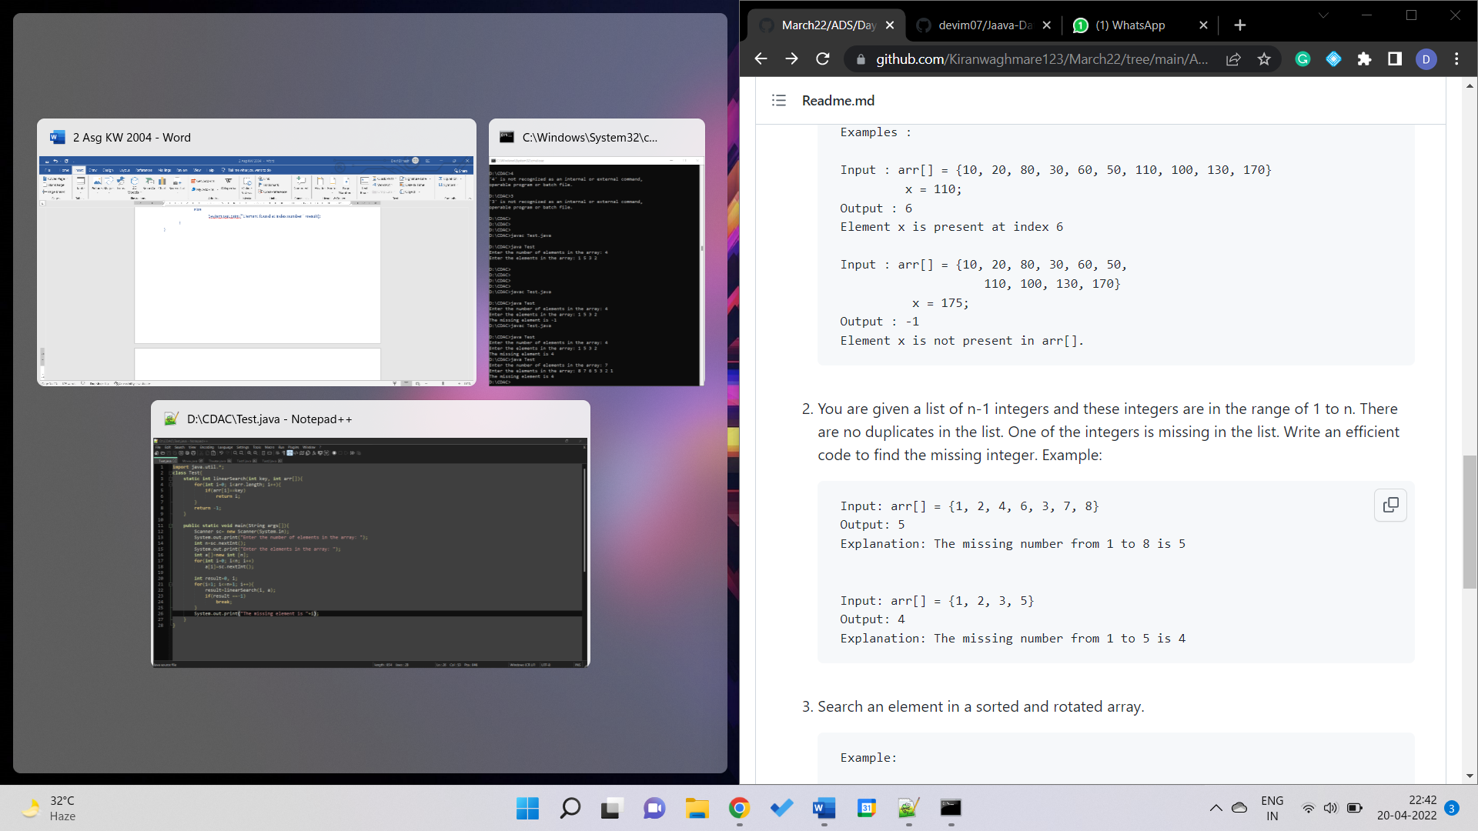

(Missing Integer 1)

import java.util.*;

class Test{

static int linearSearch(int key, int arr[]){

for(int i=0; i<arr.length; i++){

if(arr[i]==key)

return i;

}

return -1;

}

public static void main(String args[]){

Scanner sc= new Scanner(System.in);

System.out.print("Enter the number of elements in the array: ");

int n=sc.nextInt();

System.out.print("Enter the elements in the array: ");

int a[]=new int [n];

for(int i=0; i<n; i++)

a[i]=sc.nextInt();

int result=0, i;

for(i=1; i<=n+1; i++){

result=linearSearch(i, a);

if(result ==-1)

break;

}

System.out.print("The missing element is "+i);

}

}

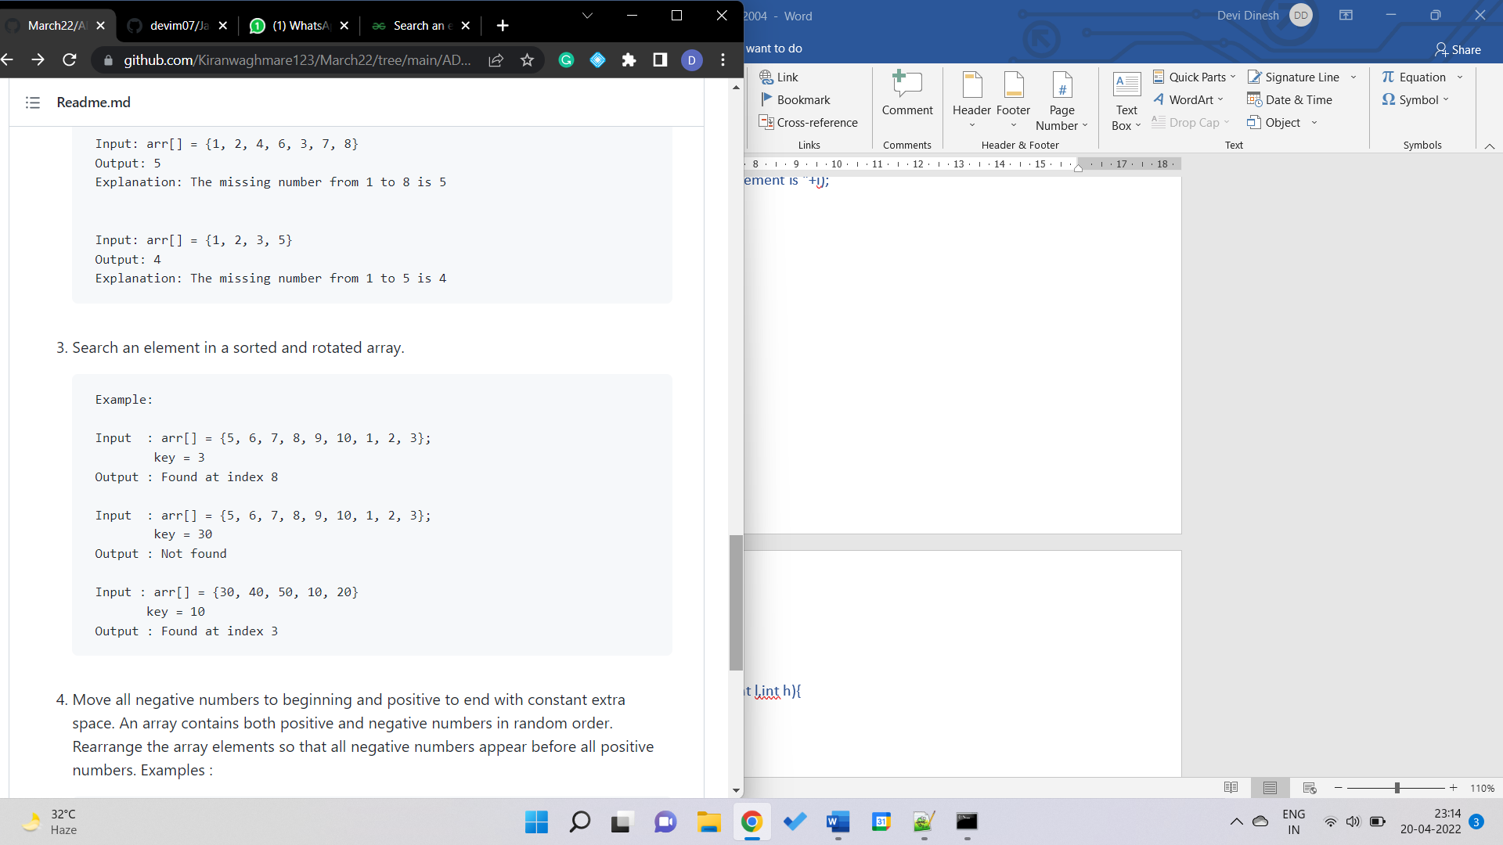

(Search an element in a sorted and rotated array 1)

import java.util.*;

class Test2{

static int binarySearch(int key, int arr[],int l,int h){

int mid=l+(h-l)/2;

if(h>=l){

if(arr[mid]==key)

return mid;

else if (arr[mid]>key)

return binarySearch(key, arr,l,mid-1);

else

return binarySearch(key, arr,mid+1,h);

}

return -1;}

public static void main(String args[]){

Scanner sc= new Scanner(System.in);

System.out.print("Enter the number of elements in the array: ");

int n=sc.nextInt(), i,k=0;

System.out.print("Enter the elements in the array: ");

int a[]=new int [n];

int sorted[]=new int[n];

for(i=0; i<n; i++)

a[i]=sc.nextInt();

System.out.print("Enter the elements you want to find: ");

int key=sc.nextInt();

for(i=0; i<n; i++){

if(a[i]>a[i+1])

break;

}

for(int j=i; j<n;j++)

sorted[k++]=a[j];

for (int j=0; j<i; j++)

sorted[k++]=a[j];

int result=binarySearch(key, sorted,0,n-1);

if(result ==-1)

System.out.print("Element NOT found");

else

System.out.print("Element found at index number "+(i+result)%n);

}

}

(Search an element in a sorted and rotated array 2)

import java.util.*;

class Test2{

static int binarySearch(int key, int arr[],int l,int h){

int mid=l+(h-l)/2;

if(h>=l){

if(arr[mid]==key)

return mid;

else if (arr[mid]>key)

return binarySearch(key, arr,l,mid-1);

else

return binarySearch(key, arr,mid+1,h);

}

return -1;

}

public static void main(String args[]){

Scanner sc= new Scanner(System.in);

System.out.print("Enter the number of elements in the array: ");

int n=sc.nextInt(), i,k=0;

System.out.print("Enter the elements in the array: ");

int a[]=new int [n];

int sorted[]=new int[n];

for(i=0; i<n; i++)

a[i]=sc.nextInt();

System.out.print("Enter the elements you want to find: ");

int key=sc.nextInt();

for(i=0; i<n; i++){

if(a[i]>a[i+1])

break;

}

int result1=binarySearch(key,a,0,i), result2=binarySearch(key,a,i+1,n-1);

if(result1==-1){

if(result2 ==-1)

System.out.print("Element NOT found");

else

System.out.print("Element found at index number "+(result2));

}else{

System.out.print("Element found at index number "+(result1));

}

}

}

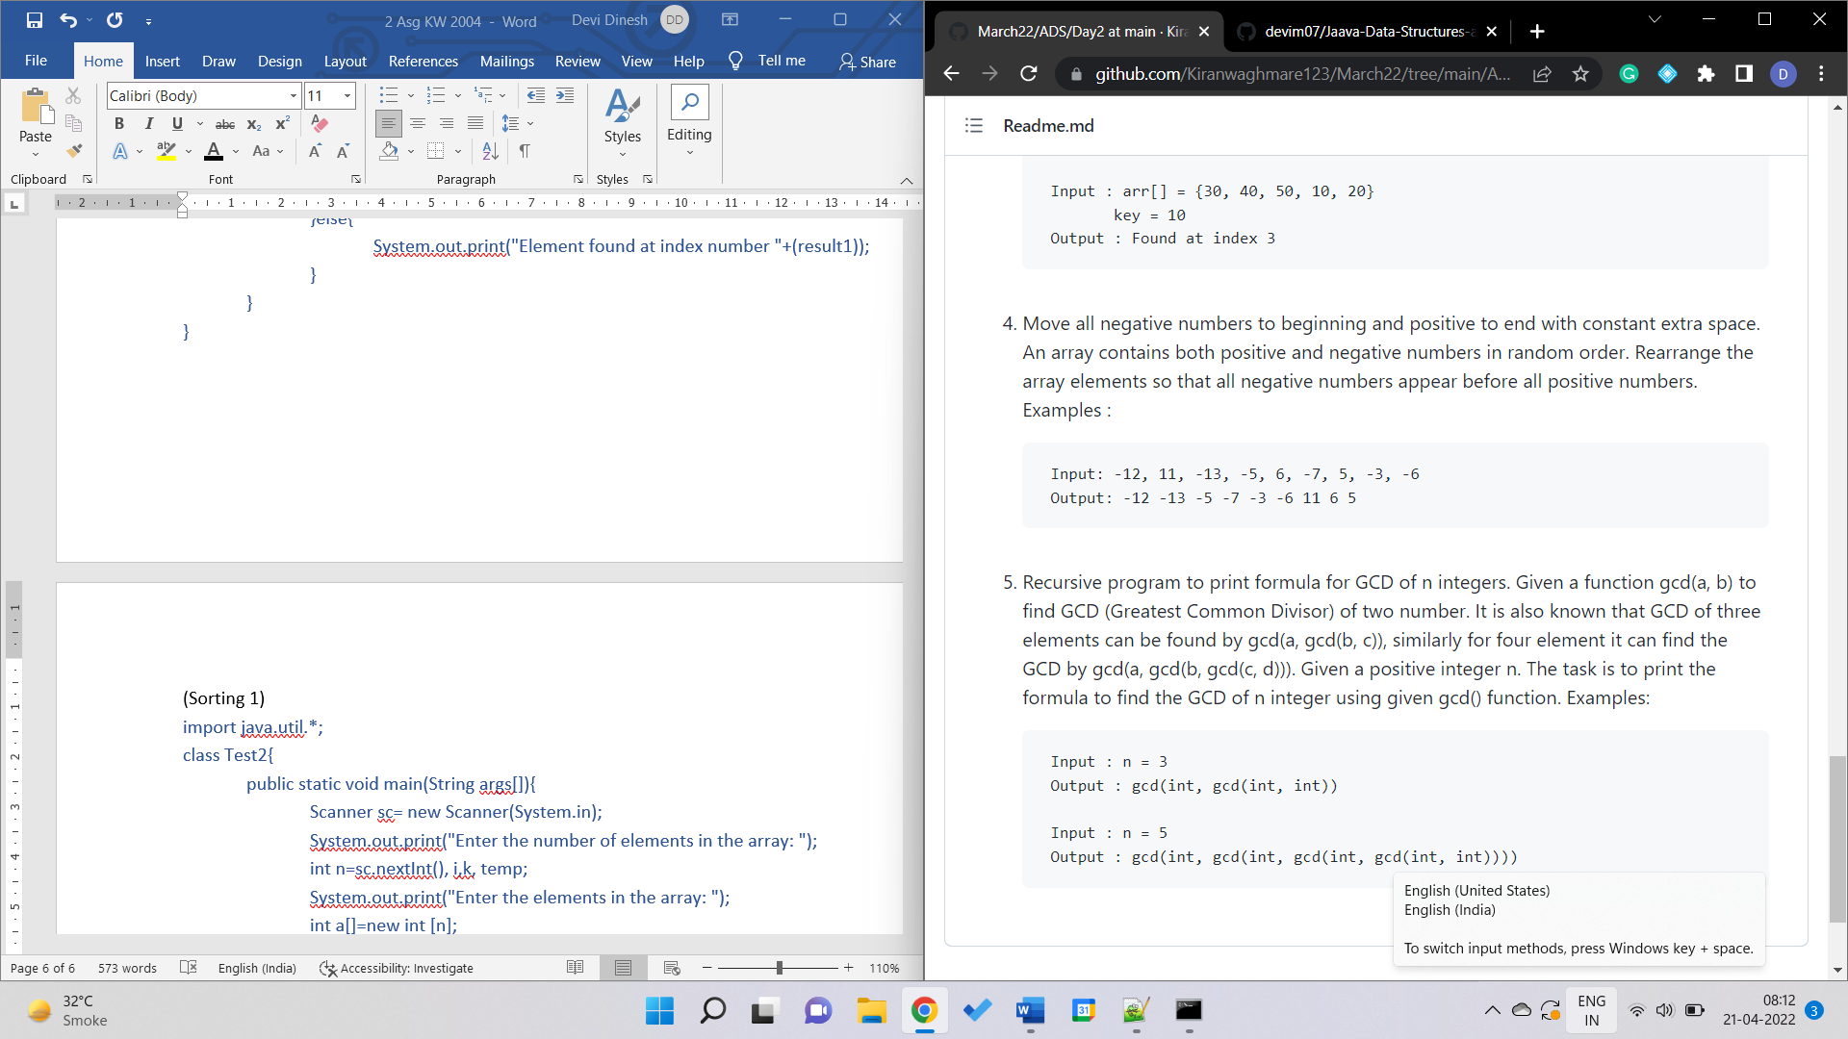

(Sorting 1)

import java.util.*;

class Test2{

public static void main(String args[]){

Scanner sc= new Scanner(System.in);

System.out.print("Enter the number of elements in the array: ");

int n=sc.nextInt(), i,k, temp;

System.out.print("Enter the elements in the array: ");

int a[]=new int [n];

for(i=0; i<n; i++)

a[i]=sc.nextInt();

for(i=0; i<n-1; i++){

for(k=i+1;k<n; k++){

if(a[i]>a[k]){

temp=a[i];

a[i]=a[k];

a[k]=temp;

}

}

}

for(i=0; i<n; i++)

System.out.print(a[i]+" ");

}

}

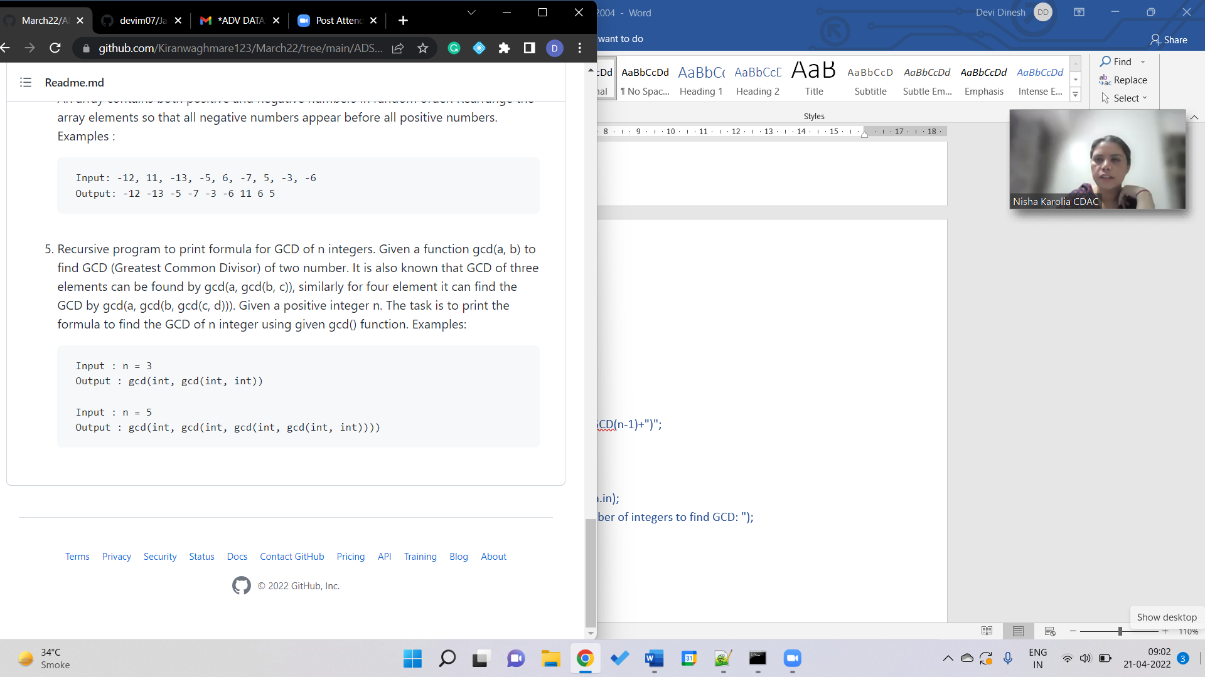

(Formula for GCD of n Integers 1)

import java.util.*;

class Test2{

static String showGCD(int n){

if(n==2)

return "gcd(int, int)";

else

return "gcd(int, "+showGCD(n-1)+")";

}

public static void main(String args[]){

Scanner sc= new Scanner(System.in);

System.out.print("Enter the number of integers to find GCD: ");

int n=sc.nextInt();;

System.out.print(showGCD(n));

}

}